**School Bus Tracker(Project Report)**

**Index**

* **Introduction**
* **Modules**
* **Resources used**
* **Application**
  + **Development of application**
  + **Working of application**
* **Conclusion**
* **References**

**Introduction**

• There are many safety concerns today

• Parents might not be knowing whether their child is going to school punctually

• Not able track the routine

• During crisis situation:like child missing,children cannot be tracked properly

• The institution sometimes not able keep track of students,whether they boarded the bus or not

* The project is a mobile app that acts as a student's boarding tracking system in school and institution vehicles.
* It is used by the bus conductors for recording the attendance of students.
* Our Bus attendance application focuses on students, knowing when the student got on and off the bus.
* So when the administrators view the data they can take appropriate actions, especially when a student goes missing.
* The scheduled boarding time and the time at which the student boarded the bus can be easily tracked using this system.
* This application helps in checking whether the student was on time or not and also brings uniformity in the students.

**Requirements**

* QR code generator
* App Creation : MIT App Inventor
* Coding platform : Google app script
* Language used : JavaScript
* QR Code scanner

**Resources Used**

[**https://www.the-qrcode-generator.com/**](https://www.the-qrcode-generator.com/)

[**https://appinventor.mit.edu/**](https://appinventor.mit.edu/)

[**https://script.google.com/home**](https://script.google.com/home)

**Modules**

* Create qr codes with student information and place it in their ID card.
* Create a qr code scanner app.
* Create a attendance sheet
* Writing a program to link app and sheet

**Dataset**

**In time Attendance sheet**

<https://docs.google.com/spreadsheets/d/1pmOeoxnhs9rqZAVNKg8cpoPm6Gwf0e0LMU4tVsS2hOc/edit#gid=0>

**Out time Attendance sheet**

<https://docs.google.com/spreadsheets/d/1VCL4vNnwetg1tcqOxNDoON48PbiVyoUvex1da3aP7EI/edit#gid=0>

**Application**

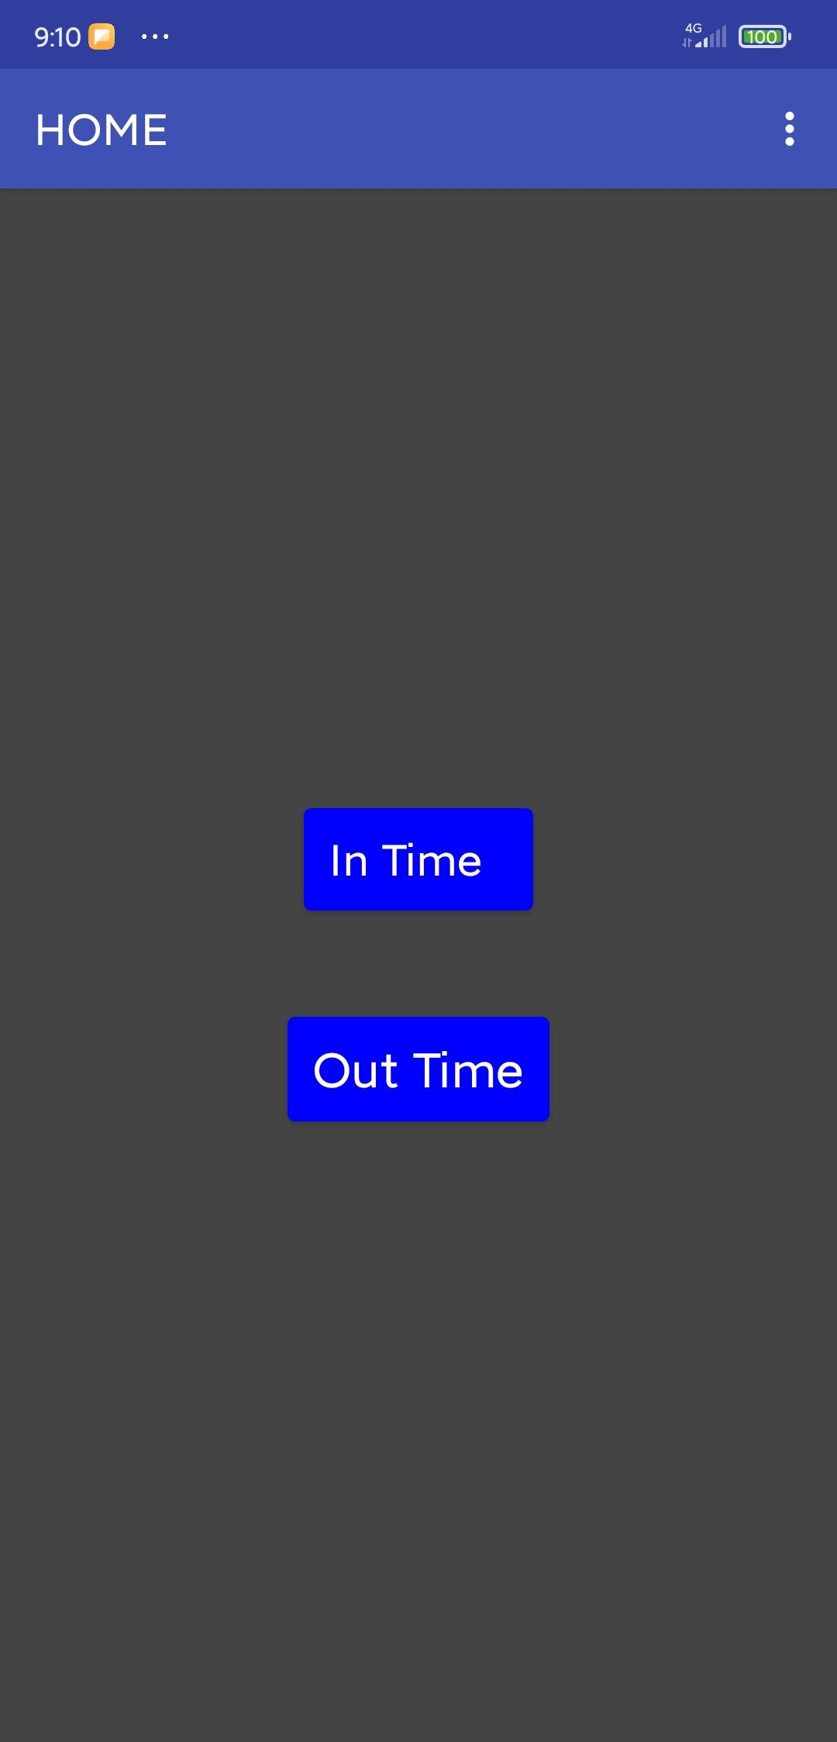

**Development of Application**

* The app for scanning and recording the attendance is made using the mit app inventor
* App Inventor lets you develop applications for Android phones using a web browser and either a connected phone or emulator. The App Inventor servers store your work and help you keep track of your projects.

**Working of the application**

* The App opens to the home screen where two buttons will be available
* The buttons are used to open qr code scanner to record time for respective boardings
* After the qr code is scanned,the data from the qr code is extracted
* The time of scanning is recorded and filled in the sheet.

**Conclusion**

* The safety concerns today is very high
* The bus attendance app helps in keeping track of the students to a certain extent.

**References**

[**https://nevonprojects.com/bus-pass-with-barcode-card-scan/**](https://nevonprojects.com/bus-pass-with-barcode-card-scan/)

[**https://www.youtube.com/watch?v=WuH-GBynC8U**](https://www.youtube.com/watch?v=WuH-GBynC8U)

[**https://youtu.be/hynTBp-3toQ**](https://youtu.be/hynTBp-3toQ)